Program: Intro to Cyber

Unit: CFC011023

**Project Goal:**

**Understanding Network Map**

**&  
Wireshark Usage**

Student No: S12  
Student Name: Ivan Wong Sen Loong

Date of completion: 13 October 2023

Contents

1.0 Methodology 3

1.0.1 Websites and Commands used for constructing network map 3

1.0.2 Website and Commands used to get ISP and OS/version 5

2.0 Side by Side comparison between the network map and ipconfig /all info 6

3.0 Wireshark sniffing into https://whatismyipaddress.com 11

## Methodology

### Websites and Commands used for constructing network map

#### Website: Draw.io

To construct the network map, I was looking for a webstie that could let me:

* Easily paste in image
* Edit Text
* Able to link an image/text to one another

And hence, draw.io has become website of choice to construct the network map

#### Commands used

As for getting the info I needed to put into the network map, I opened up CMD (Win key > type “cmd” > press enter) and typed in **“ipconfig /all”** and press enter.

 *Snippet 1.2: Command “ipconfig /all” in use*

Once I had confirmed that it displayed the following properties:

* Device Name, Internal & External IP, Mac Address, DNS and DHCP

Then I typed in **“ipconfig /all 1>my.txt”** to import all the info into a txt file. I did this so i can easily refer the info generated from ipconfig /all and copy paste the data into my network map in draw.io

 *Snippet 1.3: Command “ipconfig /all 1>my.txt” in use*

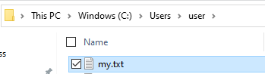  
*Snippet 1.4: The generated my.txt will appear in “C:\Users\user” directory*

#### Website: [What Is My IP Address - See Your Public Address - IPv4 & IPv6](https://whatismyipaddress.com/)

To get my external IP, I simply logged into the above website using my laptop and voila it showed this:

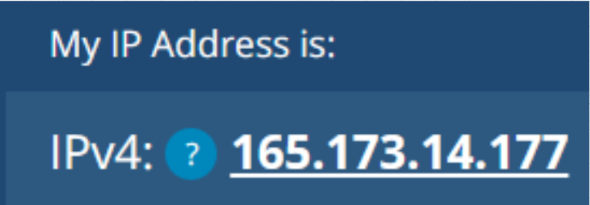

*Snippet 1.5: My external IP assigned by my router*

### Website and Commands used to get ISP and OS/version

#### Websites: [Who Is My ISP? How to Check Your ISP & Why It Matters (top10vpn.com)](https://www.top10vpn.com/tools/who-is-my-isp/)

To get my Internet Service Provider (ISP), I would click into this website and it showed me that my ISP is **StarHub Ltd**

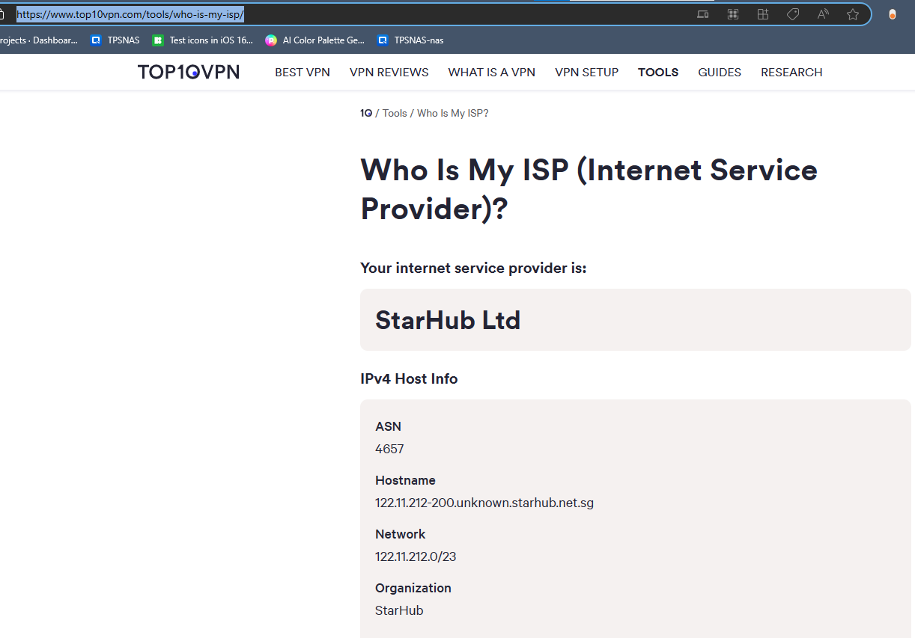

#### Command: systeminfo

With the cmd open, I typed in “systeminfo” and it had showed me relevant infos about my laptop



*Snippet 1.6: Getting my systeminfo using systeminfo*

And within the rows of data I would search for keywords like “OS” and “version” and sure enough I would see this:   
  


*Snippet 1.7: My OS name and Version shown using the systeminfo command*

## 2.0 Side by Side comparison between the network map and ipconfig /all info

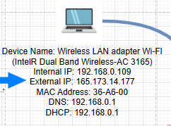

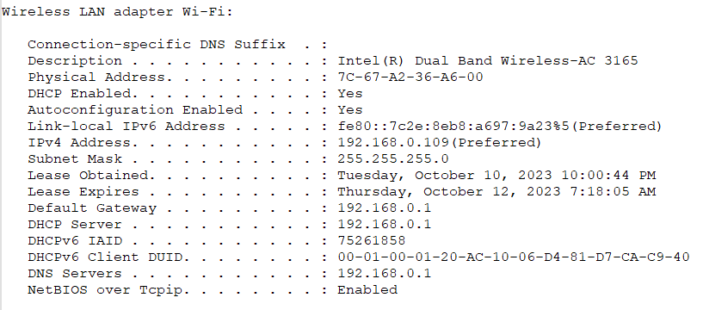

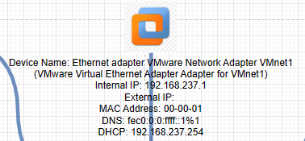

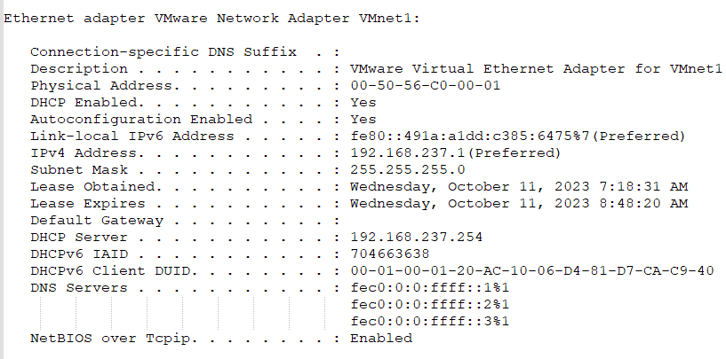

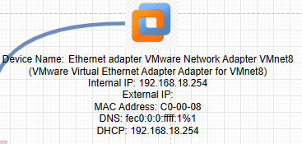

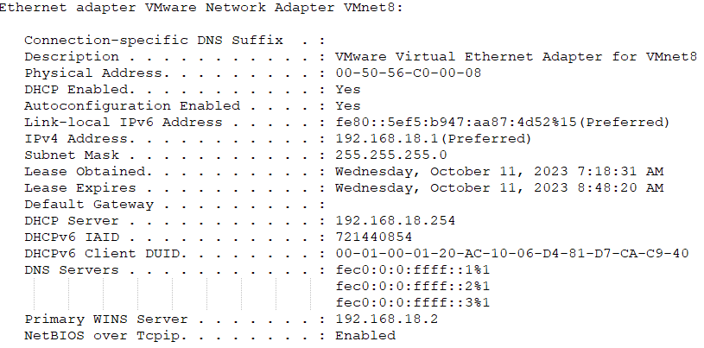

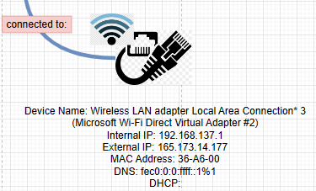

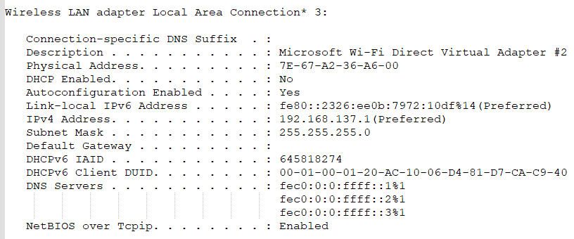

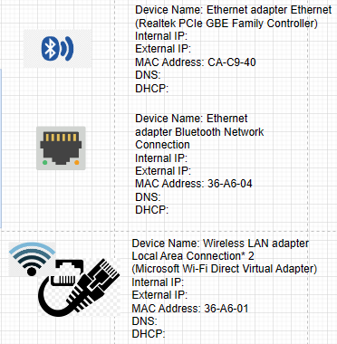

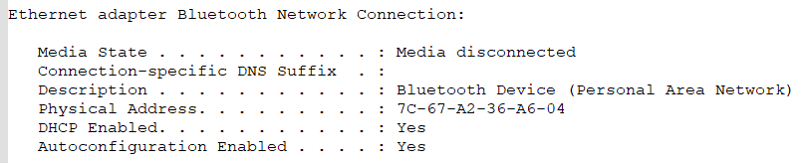

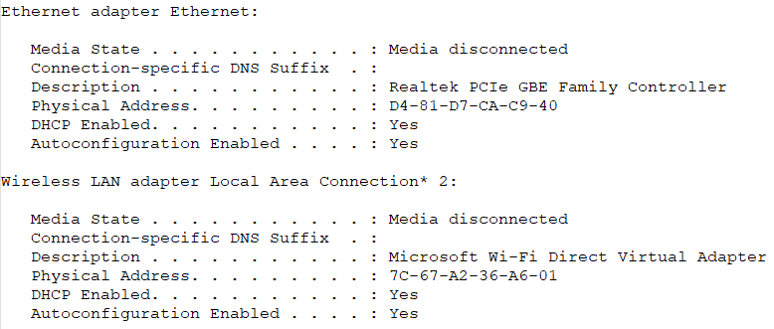

## 3.0 Wireshark sniffing into <https://whatismyipaddress.com>

The screenshot below is my attempt in using wireshark to capture the information of my laptop going into this website (<https://whatismyipaddress.com>). The website’s IP address is **172.20.10.1**

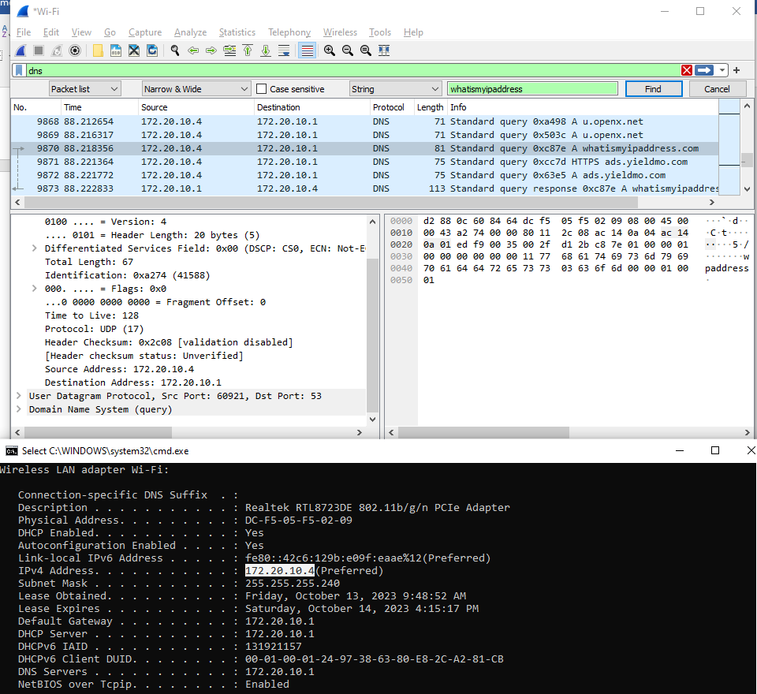

The website’s IP

My Internal IP